Clerk’s Report for
Monday 30th March 2026

Agenda item |  | Pages
3 | January minutes for approval | 2 - 4
9 (a) | Dispensation form | 5
9 (b) | Internal control policy and forms | Separate doc
11 (a) | Map of Waterloo curtilage | 6
11 (b) | Traffic and road outside Grange Hill Quarry | 7 - 11
12 (b) | GDPR data compliance form | 12

Agenda item 3 – January Minutes for approval
MINUTES: of Naunton Parish Council Meeting held on Monday 26th January 2026 at 7.00 pm.
PRESENT: Parish Councillors: Charles Hanks, Nicki Gibberson, Keith Russell, David Pickup,
APOLOGIES None as all attended.
IN ATTENDANCE: Maxi Freeman, Clerk
MEMBERS OF THE PUBLIC: One

- To receive Declarations of Interest in items on the agenda (Localism Act 2011).None.
- To hear representations from the public regarding items on the agenda. None.
- Approval of minutes of the previous meeting (November 2025) The meeting approved the minutes, and the Chairman signed them. Action: Clerk to post to website.
- Chairman’s announcements
- Clerk’s Report. Councillors noted supporting information for item 7.
- Planning applications
To comment:
26/00039/FUL Littons. Erection of residential outbuilding. Demolition of stables. Councillors had no objections to the development but noted that Corten steel roofing is not included in the Cotswold Design Code. Councillors recommended slate roofing as appropriate for a building subservient to the main house. The amount of glazing and lighting was discussed and councillors agreed that this should be reduced to maintain dark skies in the village, in keeping with the local style of buildings. Action: Clerk to post comment to planning portal. .
26/00052/FUL Cromwell House, Naunton. Conversion of detached garage to studio with office and guest accommodation. Councillors agreed that the number and extent of glazing was excessive and would damage the dark skies of the area. Action: Clerk to post comment to planning portal.
- Grit bins. Councillors decided to request new two new grit bins – one near the Naunton village sign on the road from Church Farm crossroads to the village and the second near Waterloo Farm.. Councillors chose the 200litre ‘Roadware’ heavy duty grit bin, unlocked. Councillors decided to consult residents on locations and to check with the snow warden whether further grit/salt was needed and whether the snow warden was responsible for filling the grit bins. Action: Cllr Gibberson to consult residents, Cllr Hanks to check with the Snow Warden.
- Highways – Councillors decided to report two potholes in the village on the ‘Fix it’ system. Action: Cllr Gibberson. The ditch at the Waterloo Farm end of the village was blocked. Action: Clerk to check curtilage for ownership and write to Waterloo Farm if necessary.
- Training. Moved to March meeting.
- Data Protection Training. Action: Clerk to book all councillors onto self-guided e-learning.
- Assets and risk assessment. To receive reports on council assets and decide on any action. All assets satisfactory. Action: Cllr Hanks to check whether Greenfield have carried out further works to play area.
- New email addresses and website. Councillors to provide feedback. Action: Cllr Gibberson to help Cllrs Russell and Pickup to transfer to the new email addresses. Action: Clerk to arrange for old GoDaddy website to point to the new website.
- Finances
- To receive current accounts and bank reconciliation Councillors noted current balances and approved the reconciliation. The Chairman signed the reconciliation.

- Payments. Councillors approved the following payments and noted receipts and payments made between meetings.
Epay | M Freeman | Clerk’s salary Dec/Jan | LGA 1972 s.112 (2) | £406.14
Epay | HMRC | Tax | LGA 1972 s.112 (2) | £58.40
 | M Freeman | Exes – phonebox light, X2 Connect | LGA 1892 s.8 (1)(i) | £58.80
 | GoDaddy | Website hosting Nov £23.99, Dec £23.99, January £26.39 | LGA 1972 s.142 | £74.37
 | M Freeman | Exes – printer ink | LG(FP)A 1963 s 5 | £19.50

 |  | Deposit a/c | Interest Dec, Jan 2026 |  | £0.49
Payments between meetings:
FP | DefibWarehouse |  | iPAD SP1 Auto defibrillator | LGPIHA 2007 s.77 / PC(PTPW-B)(PC) Order SI 2008/3095 | £1,074.00
PAY | Lloyds |  | Account fees x 2 months@ £4.25 p mth |  | £8.50
DD | St Andrews Church |  | Lease on VH and rec field | LGA 1972 s.133 | £1.00

Councillors agreed to allow the clerk to apply for a bank card to remove the need for personal expenses.
14. Items for the next meeting
Councillors noted that the number of lorries leaving Grange Hill Quarry seemed to have increased. Clerk will check number of lorry movements permitted at the site.

The next meeting is scheduled for 9th March 2026.

…………………………………………………………………………………..
Chairman Date 30th March 2026

Agenda item 9 (a) Request for dispensation
Councillors must submit requests for a dispensation to allow them to take part in discussions and/or vote on agenda items where they have a conflict of interest. Please complete the following form and forward it to the Clerk. The request(s) must be considered at a Council meeting.
Applicant name | Conflict of interest | Dispensation for discussion and vote or discussion only | Time period (Maximum four years) | Reason
Cllr Hanks | Village Hall | Discussion and voting | Four years | To maintain quorum at PC meetings; to enable well informed decisions on matters relating to the village hall.
Cllr Gibberson | Village Hall | Discussion and voting | Four years | To maintain quorum at PC meetings; to enable well informed decisions on matters relating to the village hall.
Cllr Russell | Village Hall | Discussion and voting | Four years | To maintain quorum at PC meetings; to enable well informed decisions on matters relating to the village hall.
Approved at a meeting of Naunton Parish Council held on 30th March 2026
Agenda item 11 (a) – Curtilage of Waterloo Farm for location of ditch
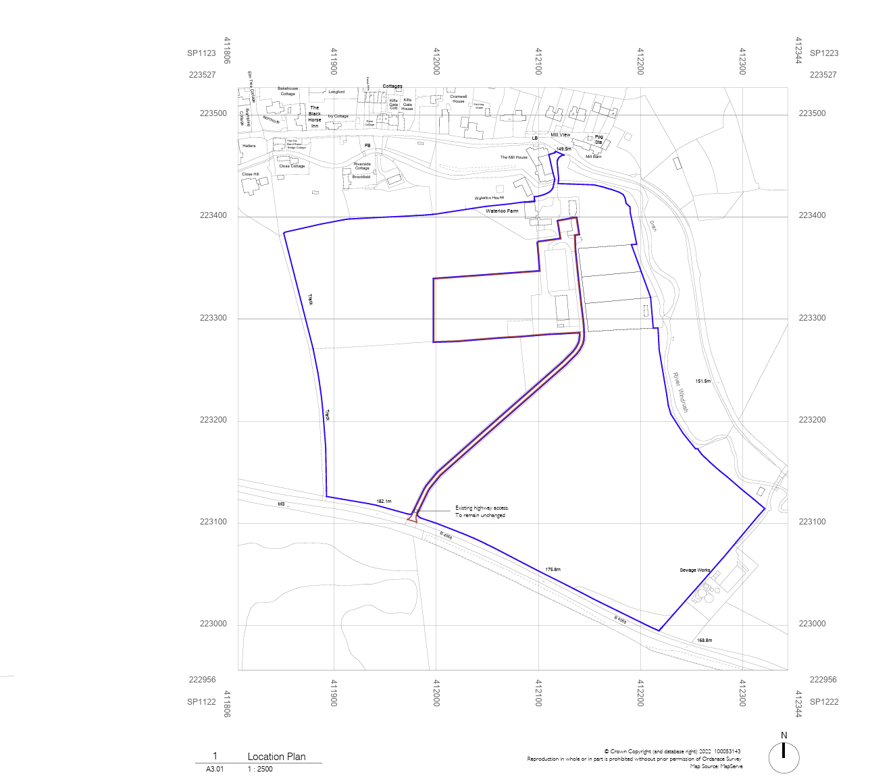

Grange Hill quarry roads
At the January meeting, Councillors expressed concern over the number of vehicles entering and leaving Grange Hill Quarry. Because there are many clauses which determine the behaviour of the quarry, I'm sending this in advance so that you have more time to consider the agenda item. I've included possible factors to consider as 'Notes' after each section.

Conditions and clauses of the operation of Grange Hill Quarry

The quarry has been operating for many years, so there are several sets of planning decisions. Regulations covering quarrying include planning regulations in the Gloucestershire Minerals Local Plan, and in the Cotswold District Local Plan, as well as recommendations in the Cotswold Landscape Management Plan. There are several clauses which apply and which Councillors should consider when deciding on any action regarding the quarry.

Conditions that might be relevant include -

*output (which affects number of vehicles. Output increases are also regulated.)
*condition of the access track and condition of the road
* safety of non-motorised users
* excessive increase in output.
The latest Decision Notice for for quarrying at Grange Hill quarry is available here: :///C:/Users/mbfre/Downloads/02359001773674685__-__Decision-Notice-22-0067PDF%20(1).pdf
The following paragraphs would seem to be most relevant:

Quarry output
Output Limit 31.
The output of mineral from the site shall not exceed a level of 16,800 tonnes in any two year period, starting from the 11th June 2020. Reason: In the interests of highway safety and in accordance with policy DM03.
Number of lorries permitted =
16,800 tonnes in any two year period
26 T per vehicle,
16,800 /26 = 646 per 2 years/ 323 per year /52 weeks = 6 per week.
But two trips per vehicle (one out and one back) = 12 trips per week on average (6 loaded, 6 empty). Quarrying can take place Mon - Fri and Sat a.m. = 2 trips per day on average.

Records 41.
From the date of this permission and throughout the course of the development hereby approved, operators shall maintain records of their monthly production of building stone and walling stone from the site as detailed in this permission, and shall make them available to the Mineral Planning Authority, at any time upon request. All records shall be kept for at least 30 months. Reason: To enable the Mineral Planning Authority to monitor output from the site and to accord with policy MW02 of the Minerals Local Plan for Gloucestershire 2018-2032.

Note: i.e. The Quarry has records of production and GCC can ask for those records. When I've asked for these figures for other quarries, I've been told that GCC doesn't have them so to get them, NPC would have to ask GCC to ask Grange Hill Quarry for them. And GCC would have to agree to get them. NPC currently has no proof that the number of quarry lorries is in excess of the calculated figure carrying 16,000 tonnes per 2 years. Do Councillors want to try to get these figures? Alternatively, do Councillors want to ask for a survey of the number of vehicle journeys on the road? HGVs can be split out from the total number.

Policy CE13 of The Cotswold Landscape Management Plan p 65 says:
In line with the recommendations in the Board’s Tranquillity Position Statement, if a development proposal would increase in traffic movements (or HGV movements) by 10% or more, this should, as a ‘rule of thumb’, be considered significant in terms of impact on tranquillity.54 The distinctive character of minor roads reflects and contributes to the character of the wider CNL and these roads are an important means for people to experience the CNL.
Note: Permission 11/0027/CWMAJM allowed production of 12,000 per year or 12,000 over a 2 year period. A 10% increase on 12,000 would be 13,200. 16,800 is 40%. Do Councillors think that tranquillity has been affected?

Condition of the access track
Highway Condition Survey 50.
Every five years, starting from the date of this permission, a Highway Condition Survey shall be carried out for the duration of the development hereby approved. The methodology for such a Highway Condition Survey shall be as set out in Appendix A (Methodology) of the Highway Condition Survey document number TN02 dated Jan 2024 that was approved by the Minerals Planning Authority under application 24/0023/COMPLI.

The survey shall be undertaken between the junction of Class 5 Highway U50527 with the Class 4 Highway U40624, and the Class 3 Highway C103 Highway approximately 2 kilometres in an easterly direction. A copy of all Highway Condition Surveys undertaken in connection with the requirements of this condition shall be submitted to the Minerals Planning Authority within three weeks of the date that each survey was carried out. A copy of each survey shall also be held on site for the duration of the development hereby approved. Reason: In the interests of highway safety and in accordance with policy DM03 of the adopted Minerals Local Plan for Gloucestershire 2018-2032, along with policy INF4 of the adopted Cotswold District Local Plan 2011-2031 and policy CE13 of the Cotswolds National Landscape Management Plan 2025-2030.

Note:
The previous planning permit required a highways survey to be carried out every year. The latest permit says every 5 years (see above). The survey should cover from the quarry entrance on the track, all the way to Buckle Street. The current survey was carried out on 12th January 2024. The photographs are available at this link:file:///C:/Users/mbfre/Downloads/24_0023_COMPLI_TECH_NOTE_HIGHWAY.pdf. They show the condition of the verges and passing places. No work was recommended and the next visual inspection should be undertaken in January 2029. There is no evidence of any other surveys having been carried out prior to 2024 (when the approved interval was every 1 year).

Roads
Policy DM03 of the Minerals Local Plan starts on page 113 of this link: https://www.gloucestershire.gov.uk/media/twmld5ql/minerals-local-plan-for-gloucestershire-2018-2032-adopted-march-2020.pdf -
Part b Highway Network
Mineral development proposals will only be permitted where public safety is not adversely affected and it can be demonstrated: - I. unacceptable impacts on the capacity and function of the strategic and local highway networks will be avoided or satisfactorily mitigated; and II. any unavoidable adverse impacts on the capacity and function of the strategic and local highway networks will not be severe.
Part c Public Rights of Way (ProW) Network and open access land Mineral development proposals will only be permitted where it can be demonstrated: - I. public rights of way routes and / or open access land will be retained and their safe use maintained, and unacceptable adverse impacts will be avoided or satisfactorily mitigated;
Notes: The track which leads to access to the site is a bridleway i.e. a PRoW. Do Councillors think the condition is an 'unacceptable adverse impact'? is 'their safe use' maintained?
Do Councillors think that there have been unacceptable impacts on the capacity/function of the local highways? Or have they been 'avoided or satisfactorily mitigated'?

Note: Policy CE13 of the Cotswold National Landscape Management plan p 65 also says:
Increasing traffic volume and vehicle sizes on the National Landscape’s roads can lead to congestion, noise and air pollution, damage to roadside verges (with consequent drainage and soil erosion issues), reduced safety for non-motorised road users and traffic ‘ratrunning’ along minor roads and through villages.
Measures to address these issues should be integral considerations in new developments and can include lowering speed limits, the provision of suitably designed speed reduction schemes, the provision of off-road routes for non-motorised users and the provision of appropriate signage.
Note: Do Councillors think that HGVs have contributed to damage to roadside verges with the consequent issues? Do Councillors think that the road is less safe now for non-motorised road users e.g. horses and walkers?

Planning permission 22/0067/CWMAJM includes a section on Highways:
13 No vehicles exiting the quarry site shall enter the public highway unless the wheels and chassis of those vehicles have been cleaned, so as to prevent the deposition of materials on the public highway. Reason: To ensure that safe and suitable access to the site is maintained in accordance with policy DM03 of the Minerals Local Plan for Gloucestershire 2018-2032, along with policy INF4 of the Cotswold District Local Plan 2011-2031, policy CE10 of the Cotswolds AONB Management Plan 2018-2023

14 No vehicle with a gross vehicle weight exceeding 26 tonnes shall be used to transport mineral products from the site. Reason: In the interests of highway safety and in accordance with policy DM03 of the Minerals Local Plan for Gloucestershire 2018-2032, along with policy INF4 of the Cotswold District Local Plan 2011-2031 and policy CE10 of the Cotswolds AONB Management Plan 2018-2023 and paragraph 108 of the National Planning Policy Framework.

15 The surfacing of the Class 5 Highway (50527) between the site entrance and the Class 4 Highway (40624) shall be maintained in a good state of repair and kept clean and free of mud and other debris at all times, until the completion of site restoration and aftercare. Reason: In the interests of highway safety and in accordance with policy DM03 of the adopted Minerals Local Plan for Gloucestershire 2018-2032, along with policy INF4 of the adopted Cotswold District Local Plan 2011-2031 and policy CE10 of the Cotswolds AONB Management Plan 2018-2023 and paragraph 108 of the National Planning Policy Framework.

16 A sign advising drivers of vehicles exiting the site to turn left at the junction of the Class 5 Highway (50527) with the Class 4 Highway (40624) shall be erected and maintained at the quarry complex exit.

Notes: Do Councillors think that quarry lorries have always been clean on entering the highway? Do Councillors think that the highway has been maintained in a 'good state of repair' and 'kept clean and free of mud and other debris'? Do Councillor think that all quarry lorries turn left towards Buckle Street?

Agenda item 12 (b) GDPR compliance form

I confirm that I do not hold:
* an electoral register from previous years
* any information about GCC or CDC councillors that is not publicly available (unless given to me for personal use)
* resident information which was given to me for use in my role as a councillor except for information given to me for a specific purpose known to the owner of the information, and where the purpose is on-going.

I confirm that I do not process data except to carry out the tasks for which the data was given to me (including emailing).

Signed ....................................................................................................

Name ..................................................................................................... (Councillor).

Date ...........................................

