Clerk’s Report for
Monday 18th May 2026

Agenda item |  | Pages
5 | March minutes for approval | 2 - 6
15 | AGAR Cert of Exemption | 7
16 | AGAR
(a) | Annual Accounts: Section 1 Annual Governance Statement2 | 8
(b) | Annual Accounts: Section 2 Accounting Statement | 9
(c) | Annual accounts: Notie of Commencement of Public Rights | 10

Item 5 – Minutes of the March meeting
- Appointment of internal auditor for the year 2025/26.
Councillors satisfied themselves that the proposed auditor (GAPTC) was independent k and qualified to audit the council and decided to appoint GAPTC as its auditor for the year 2025 – 26. Action: Clerk to inform GAPTC (now GALC).
- Highways
- Ditch at Waterloo Farm. Councillors noted that the trench had been dug and sand-bagged however the channel was still not large enough. Action: Cllr Pickup to send photographs to the clerk for a report to GCC.
- Traffic and condition of road from Grange Hill to Buckle Street
Councillors noted that GCC Highways had carried out work opposite the top of Grange Hill, next to the quarry. The condition of the verges was still very poor. In addition, silt from the quarry was flowing down into the village, blocking drainage channels to the extent that one member of public had dug a private trench across their garden to draw the water away from their home. The silt is then deposited in the river which causes water to back up to residents’ homes. Action: Clerk to check planning requirements for the quarry; Councilllors to gather photographic evidence of the issues.
The clerk summarised the current position regarding quarry traffic at Grange Hill: GCC Minerals & Waste Planning were aware that the quarry was exceeding its permitted extraction rates, leading to many more vehicle movements per day (permitted number is weight dependent - around 2 per week). Enforcement officers were working with the quarry but no penalties were being demanded. Instead, the authority has asked the quarry to apply for a new permit which will allow them to extract the amount they want. The new application is expected to:
“regularise and clarify matters relating to vehicle movements, operating hours, and associated mitigation measures. ...The operator has additionally indicated that more substantial long-term operational changes may follow, and officers have made it clear that any such proposals must include a robust and comprehensive package of mitigation and disturbance-reduction measures for the local community.”

In addition the Team leader has stated “'The purpose .... will be to properly assess and, where necessary, secure an appropriate and enforceable revised permission that better reflects and responds to the operator’s current operating intentions”.
- Data Protection
- Training. The Clerk had registered all councillors for the GDPR training as per requirements. However, some councillors had not received confirmation. Action: Clerk to check.
- GDPR statement of data compliance. Councillors signed the statement of compliance.
- Assets and risk assessment. To receive reports on council assets and decide on any action.

Recreation field and benches | Cllr Hanks reported that all planned works had been completed. Action: Clerk to request invoice. Cllr Hanks agreed to mend the goal posts. Cllr Pickup asked for 10 boxes of dog waste bags for the recreation field. Action: Clerk to order.
Play area | Cllr Hanks had mowed the play area.
Flood Monitoring | Cllr Russell reported that the river was clearing after the recent high waters but that silt from Grange Hill was building up.
Village Hall | Cllr Russell to report on Village Hall Committee meeting
Defibrillator | Cllr Gibberson has reported that Webnos has not registered the new equipment.
Phone box | Cllr Gibberson has arranged for an electrician to replace the light fitting.

- Finances
- To receive current accounts and bank reconciliation Councillors noted current balances and approved the reconciliation. The Chairman signed the reconciliation. The clerk noted that VAT to the value of £360.51 had been claimed.

- Payments. Councillors approved the following payments and noted receipts and payments made between meetings.

The following payments to be approved:
Epay | M Freeman | Clerk’s salary February/ March | LGA 1972 s.112 (2) | £552.46
Epay | HMRC | Tax | LGA 1972 s.112 (2) | £36.07
Epay | M Freeman | Expenses – February GoDaddy | LGA 1972 s.142 | £26.39

The following credits have been received:
 |  | Deposit a/c | Interest February/March 2026 |  | £0.41
Payments between meetings:
SO | PATA |  | Quarterly payroll services |  | £40.35
PAY | Lloyds |  | Account fees x 2 months @ £4.25 p mth |  | £8.50
DD | PWLB |  | Village Hall loan repayment |  | £1616.95

- Items for the next meeting:
Councillors noted that trees were overhanging on Summer Hill and blocking views for drivers. Cllr Hanks agreed to provide photographs for a report to GCC. Cllr James reported that she had not received confirmation from the bank that she was now registered as a signatory.

The next meeting is scheduled for 18th May 2026.

…………………………………………………………………………………..
Chairman Date 18th May 2026

Item 15 – Certificate of Exemption
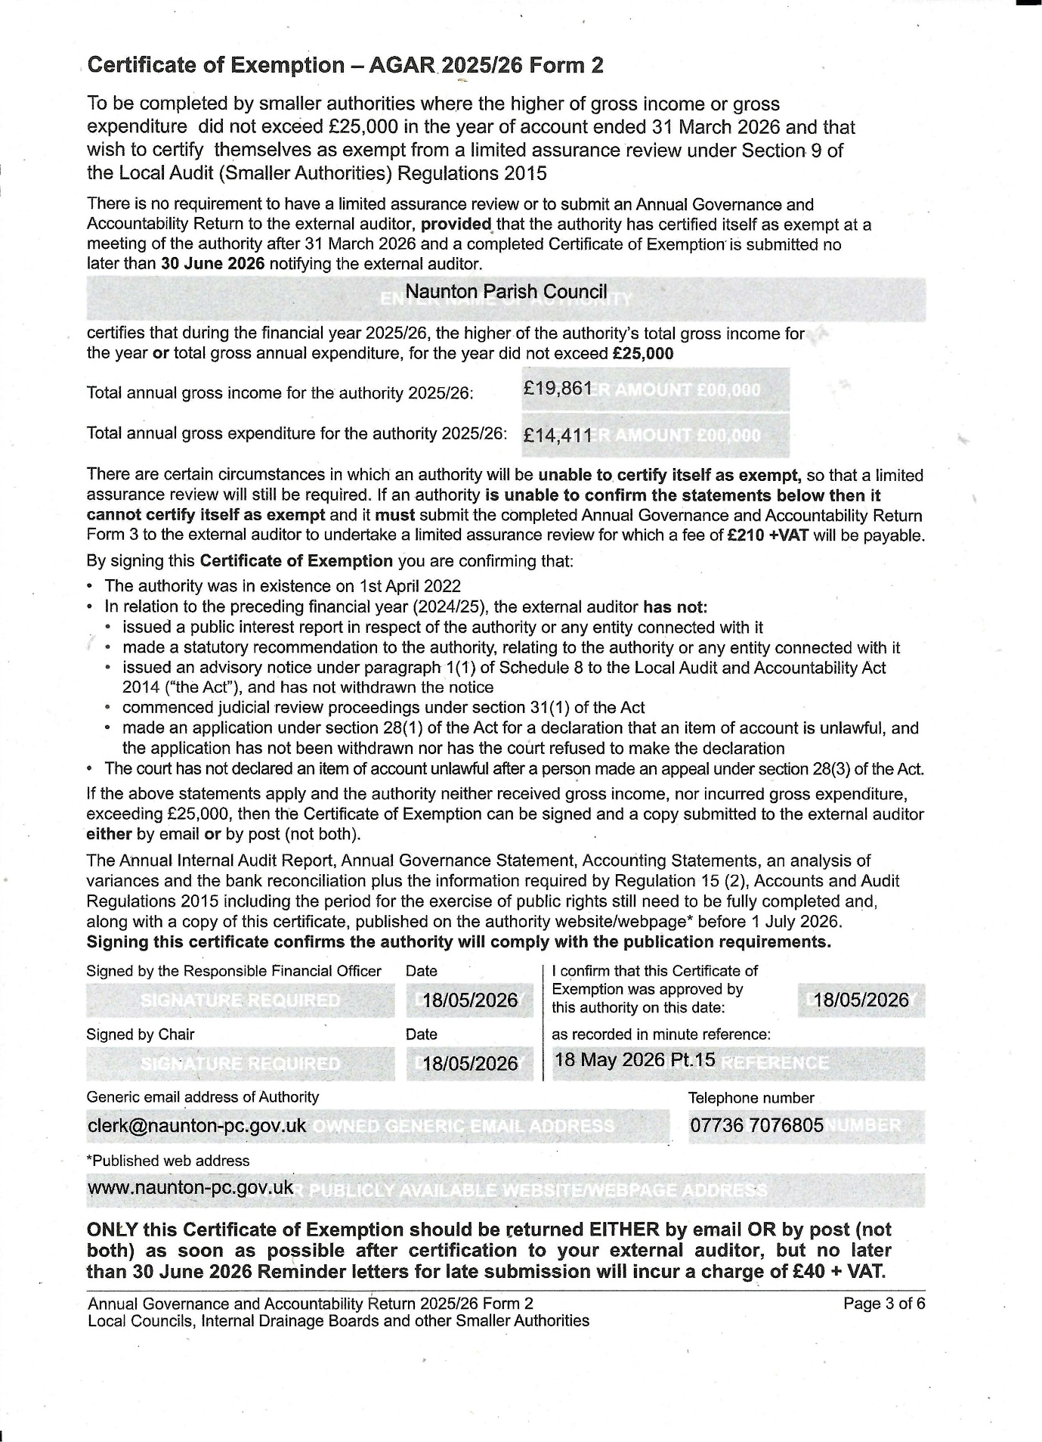

Item 16 (a)
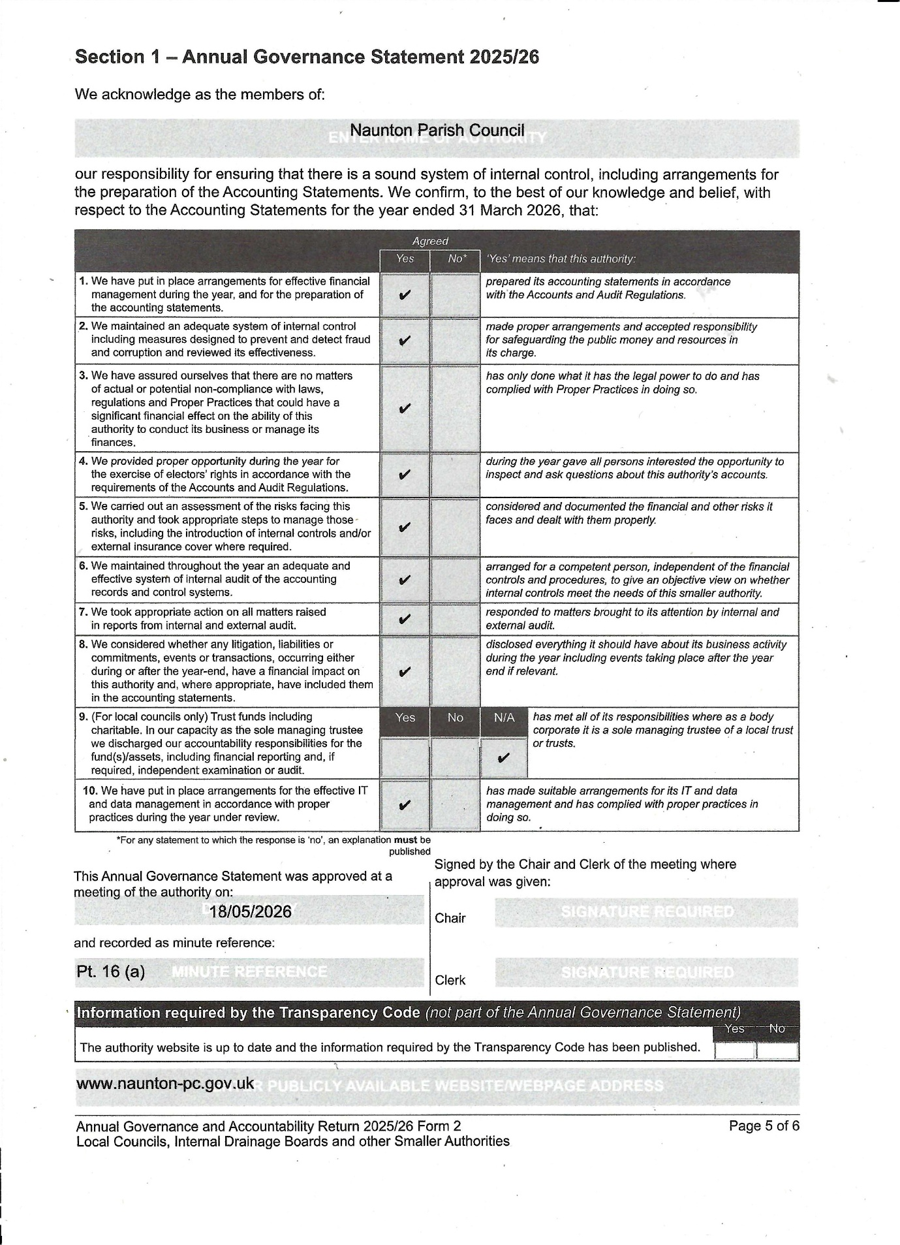

Item 16 (b)
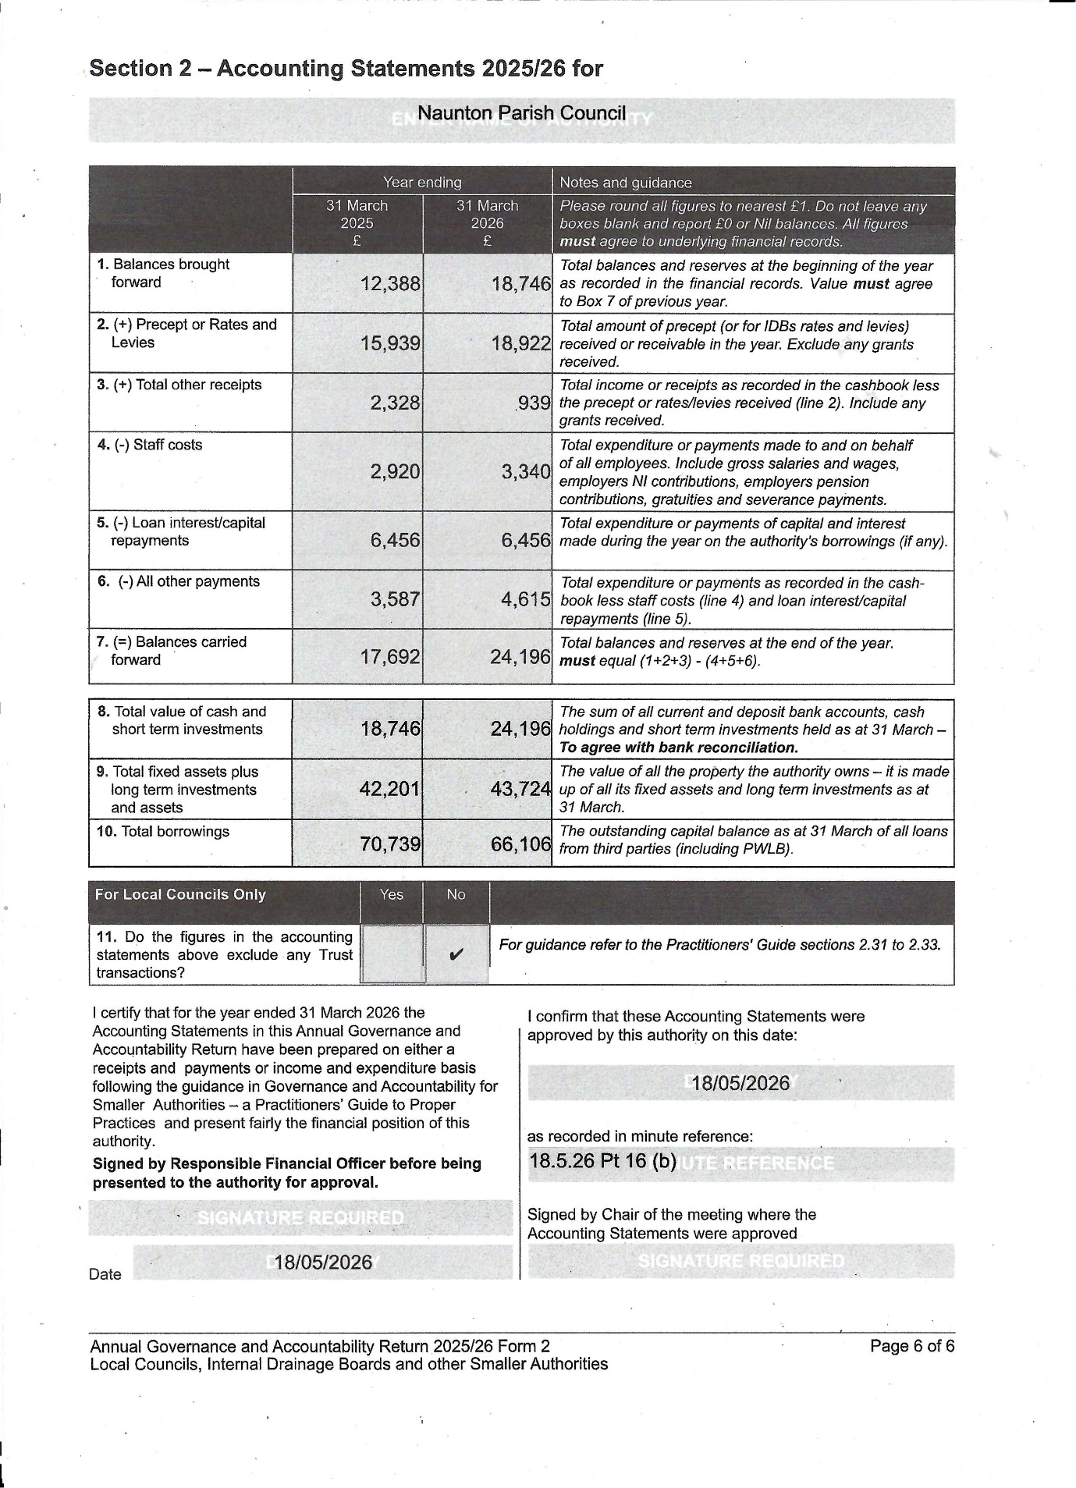

Item 16 (c)
